FII Market Entry Requirements for Malaysia
Important |  | Account structure Trust: omnibus for trading equities, segregated for trading fixed income  All investors, both residents and non-residents (excluding individual investors) investing in Malaysian debt securities should open RENTAS segregated account. The account holder is deemed the beneficial owner of the securities. For Trust, all segregated securities accounts will be linked to the omnibus cash account.  Note: As part of the FII account opening process, all documentation must show exactly the same investor name.
Fees |  | None
Tax Consultant |  | Not required
E-signature |  | Not applicable

Account Opening
Documentation Required by the Agent
- Document supporting the name of the applicant – by email
- Client’s information – by email
1. Full name of the beneficial owner
2. Tax Domicile
3. Country of incorporation
4. Identification number/Business registrations number
5. Legal Entity Identifier (LEI)
6. Registered address
7. Date of birth / Date of Incorporation
8. Investor Type (refer to list below)
9. Will you invest in Fixed Income

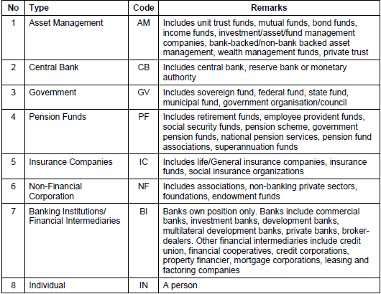
Timing | The market timeframe for opening accounts is 5 business days post completion and acceptance of documents by the agent. The executed documents received from the client may be sent for further certification or legalization affecting the turnaround time for market application. The documents may also be subject to regulatory and KYC checks and additional documents may be requested by the agent/market authorities, which could potentially extend the normal processing time.
Sub-custodian | RBC IS has appointed SCB, Kuala Lumpur as Sub-custodian. Their role is to open and manage the securities account.
Further Details | None

Name change
Documentation Required by the Agent
- Official document showing the change of name – to be certified true copy by the Global Custodian

Account Closure
No documentation required however, client should always ensure there are no outstanding trades, corporate actions, fees and holdings prior to sending the closure instruction.

Disclaimer
© Copyright Royal Bank of Canada 2023. RBC Investor Services™ is a global brand name operating primarily through the following companies: Royal Bank of Canada and RBC Investor Services Trust and their branches and affiliates. In the United Kingdom (UK), RBC Investor Services operates through RBC Investor Services Trust, UK Branch, authorized and regulated by the Office of the Superintendent of Financial Institutions of Canada. Authorized by the Prudential Regulation Authority. Subject to regulation by the Financial Conduct Authority and limited regulation by the Prudential Regulation Authority. Details about the extent of our regulation by the Financial Conduct Authority and the Prudential Regulation Authority are available on request. RBC Offshore Fund Managers Limited is regulated by the Guernsey Financial Services Commission in the conduct of investment business. Registered company number 8494. RBC Fund Administration (CI) Limited is regulated by the Jersey Financial Services Commission in the conduct of fund services and trust company business in Jersey. Registered company number 52624. This document is provided for general information and does not necessarily reflect individual circumstances. It does not constitute financial, tax, legal or accounting advice, and should not be relied upon in that regard. This document must not be reproduced, forwarded or otherwise made available to any third party outside the recipient’s organization without the express written consent of RBC Investor Services. Links to external websites are for convenience only. RBC Investor Services does not review, endorse, approve, control or accept any responsibility for the content of those sites. Linking to external websites is at your own risk. ® / ™ Trademarks of Royal Bank of Canada. Used under licence.

