Re: Bondholder Information Request

"France (FR) French Companies Act Law 2001 - 4220 of 15 May 2002, and there is reference to ""TPIs"" (i.e. titres au porteur identifiables) or FR with ref French Appendix 1.1, Chapter VI, Article 119, Book II of the Commercial Code, Article L-228.2,
"We ask you pursuant the above Act to provide us with the details of your interest in Atos SE below:
ISIN | Coupon | Maturity | Currency | Amount Outstanding
FR0013378452 | 1.75% | 2025 | EUR | 750,000,000
FR0125601643 | 1.13% | 2026 | EUR | 50,000,000
FR0013378460 | 2.50% | 2028 | EUR | 350,000,000
FR0014006G24 | 1.00% | 2029 | EUR | 800,000,000

Atos SE has appointed D.F. King, an Orient Capital Company, as an Identification Agent to assist with the identification of beneficial owners, in the context of the current ongoing efforts for them compile a list of their bondholders, the information is vital for corporate communications with their bondholders. We request beneficial owners or investment managers to disclose their identity and holding to the Identification Agent.

Any information provided is considered strictly non-public and confidential and will only ever be used by the company. It will not be entered into any public databases.
If you are unable to process this request, please pass it to the relevant contact at your firm or advise us that you are unable to respond (details below).
Please address all replies and queries to BondID@orientcap.com.

Note – responding to this request will not result in any blocking of your securities.

Yours faithfully,
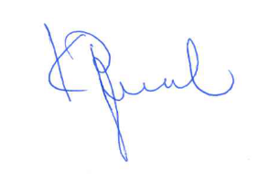
Katerina Papamichael
Agent for the company

(See attached letter of authority)

