Re: Bondholder Information Request

Pursuant to the Securities Exchange Act of 1934 - Section 13.
We ask you pursuant the above Act to provide us with the details of your interest in Exxon Mobil Corporation below:
ISIN | Coupon | Maturity | Currency | Amount Outstanding
XS2196322155 | 0.142% | 26 June 2024 | EUR | 1,500,000,000
XS2196322312 | 0.524% | 26 June 2028 | EUR | 1,000,000,000
XS2196322403 | 0.835% | 26 June 2032 | EUR | 1,000,000,000
XS2196324011 | 1.408% | 26 June 2039 | EUR | 1,000,000,000

Exxon Mobil Corporation has appointed D.F. King, an Orient Capital Company, as an Identification Agent to assist with obtaining the number of bondholders and total aggregate holdings by residents of Canada for regulatory reporting purposes, therefore we kindly as you to disclose:
- the principal amount of your aggregate holding in each of the above bonds
- the principal amount held on behalf of Canadian residents in each of the above bonds
- the number of underlying bondholders which are Canadian residents on whose behalf you are holding bonds

Any information provided is considered strictly non-public and confidential and will only ever be used by the company. It will not be entered into any public databases.
If you are unable to process this request, please pass it to the relevant contact at your firm or advise us that you are unable to respond (details below).
Please address all replies and queries to BondID@orientcap.com.

Note – responding to this request will not result in any blocking of your securities.

Yours faithfully,
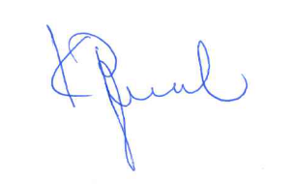
Katerina Papamichael
Agent for the company

(See attached letter of authority)

