Registration details format table
In the registration details format table below, although some of the fields are optional, customers are
requested to send as much information as possible.
Qualifier format rule:
/Qualifier followed by a “space” and then the value starts, for example: /HTYP 03/NAME John/
Example:

:70E::REGI///HTYP 03/NAME Smith/FNAM John/ICER 13090/CDCO DEU/STRE Flower street 61/CDPO 65760/CITY Eschborn
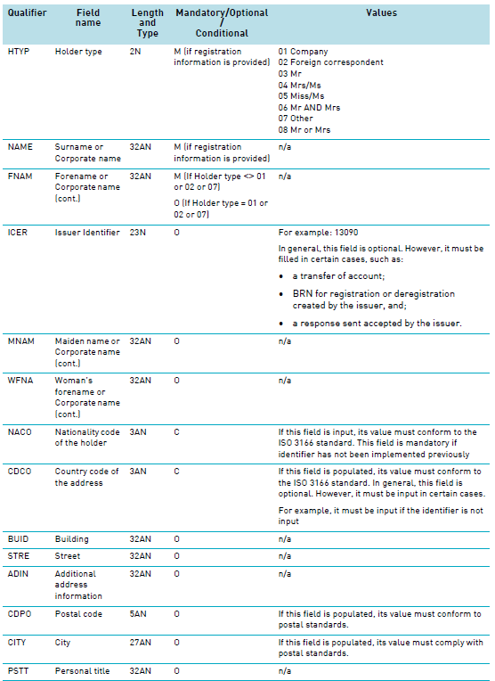

Please also see Customer Announcement C19012 dd. 05/06/2019
https://www.clearstream.com/clearstream-en/products-and-services/settlement/c19011-1530254

